Human – Omnivore – Producer and Consumer, Eat All Kinds of Sea Animals and Sea Plants

Killer Whale -

Carnivore – Consumer, Eat Sea Creatures

Marine Food Web Project by Loz McKenzie

BY

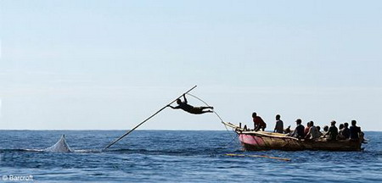

[This Photo](http://www.mjjq.com/blog/archives/1681.html) by Unknown Author is licensed under [CC BY-SA-NC](https://creativecommons.org/licenses/by-nc-sa/3.0/)

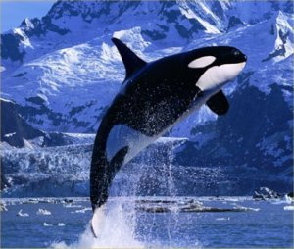

[This Photo](http://dol.ajgraves.com/2012/06/another-childhood-dream-dies/) by Unknown Author is licensed under [CC BY-ND](https://creativecommons.org/licenses/by-nd/3.0/)

Shark – Carnivore – Consumer, Eat Invertebrates and Mammals.

Large Shark – Carnivore – Consumer, Eat on Other Fish and Smaller Sharks

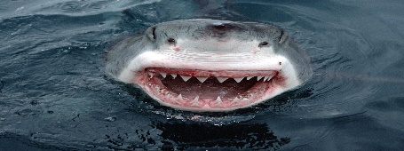

[This Photo](https://conservationbytes.com/2015/06/25/grim-tale-of-global-shark-declines/) by Unknown Author is licensed under [CC BY-NC-ND](https://creativecommons.org/licenses/by-nc-nd/3.0/)

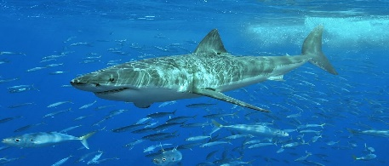

Jellyfish – Carnivore – Consumer, Eat Small Fish and Anything That Can Fit in Their Mouth

Bigger Fish – Carnivore – Consumer, Eat Algae and Small Fish

Sea Turtle – Omnivore – Consumer, Eats Fish and Plants

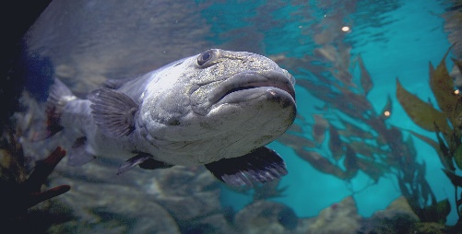

[This Photo](https://en.wikipedia.org/wiki/Giant_sea_bass) by Unknown Author is licensed under [CC BY-SA](https://creativecommons.org/licenses/by-sa/3.0/)

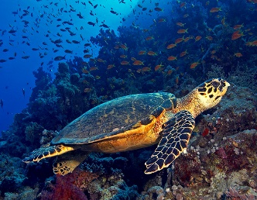

[This Photo](http://davaocitybybattad.blogspot.sg/2011/07/marine-turtle-sanctuary-in-punta.html) by Unknown Author is licensed under [CC BY-SA-NC](https://creativecommons.org/licenses/by-nc-sa/3.0/)

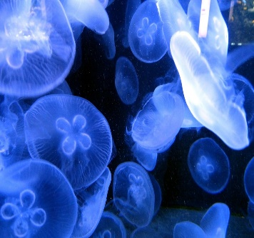   
 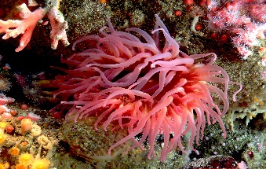

Plankton – Herbivores – Producer, Take in Carbon Dioxide and Produce Oxygen

Seahorse – Omnivore – Consumer, Eats Shrimp and Plankton

Small Fish – Carnivores – Consumer, Eats Plankton and Shrimp

Sea Slugs – Herbivores – Decomposer, Eat Plankton

Anemone – Carnivore, Consumer, Eat Fish

Fungi – Decomposer They live on organic wastes of dead plant and animal matter

Crab – Omnivore – Producer, Eat Seahorses

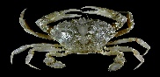

[This Photo](https://en.wikipedia.org/wiki/Crab) by Unknown Author is licensed under [CC BY-SA](https://creativecommons.org/licenses/by-sa/3.0/)

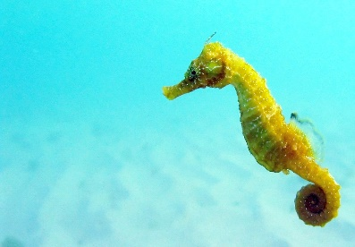

[This Photo](http://commons.wikimedia.org/wiki/File:Black_Sea_fauna_Seahorse.JPG) by Unknown Author is licensed under [CC BY-SA](https://creativecommons.org/licenses/by-sa/3.0/)

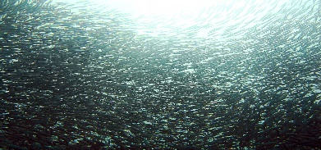

[This Photo](https://en.wikipedia.org/wiki/Sardine) by Unknown Author is licensed under [CC BY-SA](https://creativecommons.org/licenses/by-sa/3.0/)

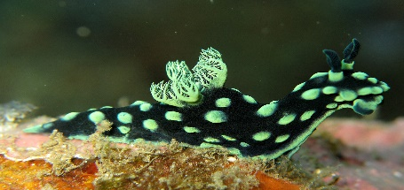

[This Photo](https://en.wikipedia.org/wiki/Nembrotha_cristata) by Unknown Author is licensed under [CC BY-SA](https://creativecommons.org/licenses/by-sa/3.0/)

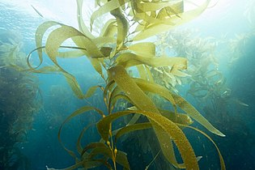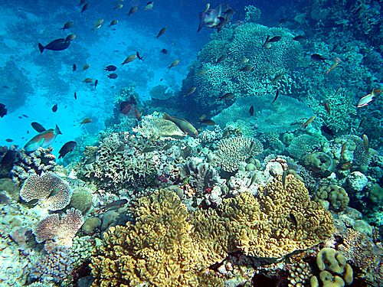

[This Photo](http://en.wikibooks.org/wiki/High_School_Earth_Science/The_Seafloor) by Unknown Author is licensed under [CC BY-SA](https://creativecommons.org/licenses/by-sa/3.0/)